**1.0 Address Class Identification**

**Address Class**

10.250.1.1 __A

150.10.15.0 __B

192.14.2.0 __C

148.17.9.1 __B

193.42.1.1 __C

126.8.156.0 __A

220.200.23.1 __C

230.230.45.58 __C

177.100.18.4 __B

119.18.45.0 _ __B

249.240.80.78 __E

199.155.77.56 __B

117.89.56.45 __A

215.45.45.0 __C

199.200.15.0 __C

95.0.21.90 __A

33.0.0.0 __A

158.98.80.0 __B

219.21.56.0 __C

2.0 Using the IP address and subnet mask shown write out the network address:

188.10.18.2 _____________________________188.10.0.0

255.255.0.0

10.10.48.80 _____________________________10.10.48.0

255.255.255.0

192.149.24.191 ___________________________ 192.149.24.0

255.255.255.0

150.203.23.19 ____________________________150.203.0.0

255.255.0.0

10.10.10.10 ______________________________ 10.0.0.0

255.0.0.0

186.13.23.110 _____________________________186.13.23.0

255.255.255.0

223.69.230.250 _____________________________223.69.0.0

255.255.0.0

200.120.135.15 _____________________________200.120.135.0

255.255.255.0

27.125.200.151 ____________________________ 27.0.0.0

255.0.0.0

199.20.150.35 _____________________________ 199.20.150.0

255.255.255.0

191.55.165.135 _____________________________191.55.165.0

255.255.255.0

28.212.250.254 _____________________________ 28.212.0.0

255.255.0.0

Host address = Block size – 2

3.0 Subnetting

1. Number of needed usable hosts 14 ===

Network Address 192.168.50.0

|  |  |  |  |  |
| --- | --- | --- | --- | --- |
| **Subnets** | **Network Address** | **Subnet Mask** | **Usable host (14)** | **Broadcast Address** |
| 1 | 192.168.50.0 | 225.225.225.240 | 192.168.50.1 – 192.168.50.14 | 192.168.50.15 |
| 2 | 192.168.50.16 | 225.225.225.240 | 192.168.50.17 – 192.168.50.30 | 192.168.50.31 |
| 3 | 192.168.50.32 | 225.225.225.240 | 192.168.50.33 – 192.168.50.46 | 192.168.50.47 |

1. Number of needed usable hosts 60

Network Address 165.100.0.0

|  |  |  |  |  |
| --- | --- | --- | --- | --- |
| **Subnets** | **Network Address** | **Subnet Mask** | **Usable host** | **Broadcast Address** |
| 1 | 165.100.0.0 | 255.255.0.192 | 165.100.0.1 – 165.100.0.63 | 165.100.0.63 |
| 2 | 165.100.0.64 | 255.255.0.192 | 165.100.0.65 – 165.100.0.127 | 165.100.0.127 |
| 3 | 165.100.0.128 | 255.255.0.192 | 165.100.0.129 – 165.100.0.190 | 165.100.0.191 |

1. Number of needed subnets 6

Network Address 210.100.56.0

Subnet = 23 – 2 =8-2 =6

Block size= 32

Note: IP subnet zero allows us to have 8 subnets. If not enabled we have just 6

|  |  |  |  |  |
| --- | --- | --- | --- | --- |
| **Subnets** | **Network Address** | **Subnet Mask** | **Usable host** | **Broadcast Address** |
| 1 | 210.100.56.0 | 255.255.255.224 |  | 210.100.56.31 |
| 2 | 210.100.56.32 | 255.255.255.224 |  | 210.100.56.63 |
| 3 | 210.100.56.64 | 255.255.255.224 |  | 210.100.56.95 |
| 4 | 210.100.56.96 | 255.255.255.224 |  | 210.100.56. 127 |
| 5 | 210.100.56.128 | 255.255.255.224 |  | 210.100.56. 157 |
| 6 | 210.100.56.160 | 255.255.255.224 |  |  |
| 7 | 210.100.56. 192 |  |  |  |
| 8 | 210.100.56. 224 |  |  |  |

1. Number of needed usable hosts 30

Network Address 195.85.8.0

|  |  |  |  |  |
| --- | --- | --- | --- | --- |
| **Subnets** | **Network Address** | **Subnet Mask** | **Usable host** | **Broadcast Address** |
| 1 | 195.85.8.0 | 255.255.255.224 | 195.85.8.1 - 195.85.8.30 | 195.85.8.31 |
| 2 | 195.85.8.32 | 255.255.255.224 | 195.85.8.33 - 195.85.8.62 | 195.85.8.63 |
| 3 | 195.85.8.64 | 255.255.255.224 | 195.85.8.65 - 195.85.8.94 | 195.85.8.95 |

1. Number of needed usable hosts 15

Network Address 178.100.0.0

Block size =32

We cannot not have block size of 16 because 24 – 2 =14.  
So we use 25 – 2 = 30. Which leaves us with extra 15

|  |  |  |  |  |
| --- | --- | --- | --- | --- |
| **Subnets** | **Network Address** | **Subnet Mask** | **Usable host** | **Broadcast Address** |
| 1 | 178.100.0.0 | 255.255.255.224 | 178.100.0.1 - 178.100.0.30 | 178.100.0.31 |
| 2 | 178.100.0.32 | 255.255.255.224 | 178.100.0.33 - 178.100.0.62 | 178.100.0.63 |
| 3 | 178.100.0.64 | 255.255.255.224 | 178.100.0.65 - 178.100.0.95 | 178.100.0.96 |

1. Number of needed usable hosts 45

Network Address 200.175.14.0

26 – 2 = 60

Block size = 64

Tis leave us with extra 15 usable addresses

|  |  |  |  |  |
| --- | --- | --- | --- | --- |
| **Subnets** | **Network Address** | **Subnet Mask** | **Usable host** | **Broadcast Address** |
| 1 | 200.175.14.0 | 255.255.255.192 | 200.175.14.1 - 200.175.14.62 | 200.175.14.63 |
| 2 | 200.175.14.64 | 255.255.255.192 | 200.175.14.65 - 200.175.14.126 | 200.175.14.127 |
| 3 | 200.175.14.128 | 255.255.255.192 | 200.175.14.129 - 200.175.14.190 | 200.175.14.191 |

4.0 Practical Subnetting

i) Based on the information in the graphic shown, design a network addressing scheme that will supply the **minimum number of hosts per subne**t, and allow enough extra subnets and hosts for 30% growth in all areas. Circle each subnet on the graphic and answer the questions

below.

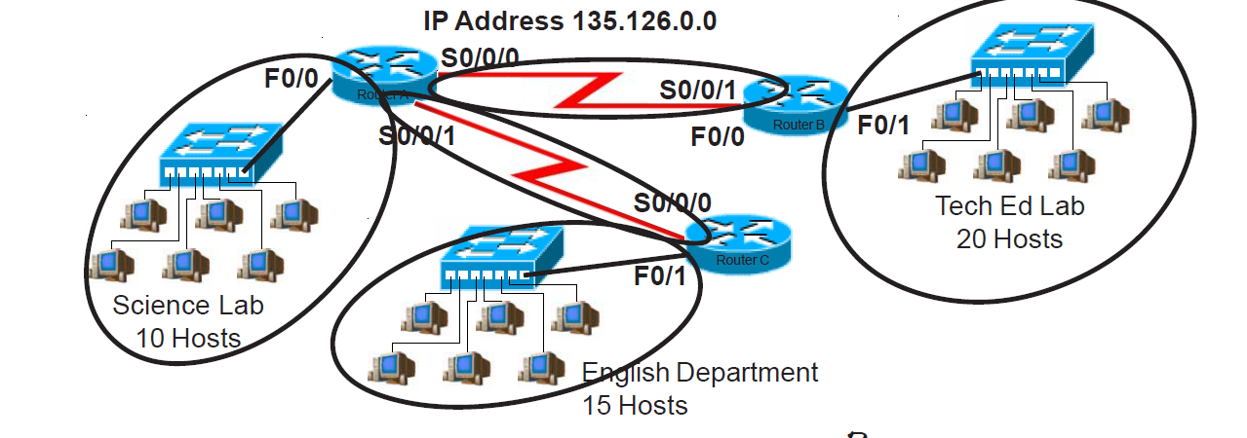

**Solution:**

The Ip address135.126.0.0 is Class B which is SM 255.255.0.0 (Over 65,000 hosts)

To create extra subnet and that allow for at least 30% growth; we would subnet the IP block to /27 which is a block size of 32

|  |  |  |  |  |
| --- | --- | --- | --- | --- |
| **Subnets** | **Network Address** | **Subnet Mask** | **Usable host (32)** | **Broadcast Address** |
| 0 | 135.126.0.0 | 255.255.255.224 | **135.126.0.1 - 135.126.0.30** | 135.126.0.31 |
| 1 | 135.126.0.32 | 255.255.255.224 | **135.126.0.1 - 135.126.0.30** | 135.126.0.63 |
| 2 | 135.126.0.64 | 255.255.255.224 | **135.126.0.1 - 135.126.0.30** | 135.126.0.95 |
| 3 | 135.126.0.96 | 255.255.255.224 | **135.126.0.1 - 135.126.0.30** | 135.126.0.127 |

Based on the above table, we choose to do the following assignment,

* **Tech Ed Lab** = subnet 1 === 30 hosts. (Allows for about 50% expansion)

|  |  |  |  |  |
| --- | --- | --- | --- | --- |
| **Subnets** | **Network Address** | **Subnet Mask** | **Usable host** | **Broadcast Address** |
| 1 | 135.126.0.32 | 255.255.255.224 | **135.126.0.1 - 135.126.0.30** | 135.126.0.63 |

* **English Department:** = subnet 2 == 30 hosts (which allows for 100% growth)

|  |  |  |  |  |
| --- | --- | --- | --- | --- |
| **Subnets** | **Network Address** | **Subnet Mask** | **Usable host (14)** | **Broadcast Address** |
| 2 | 135.126.0.64 | 255.255.255.224 | **135.126.0.1 - 135.126.0.30** | 135.126.0.95 |

Now we will take the subnet 135.126.0.96 255.255.255.224. and break it down further to get a block of 16 hosts for science lab.

|  |  |  |  |  |
| --- | --- | --- | --- | --- |
| **Subnets** | **Network Address** | **Subnet Mask** | **Usable host** | **Broadcast Address** |
| 0 | 135.126.0.96 | 255.255.255.240 | **135.126.0.97 - 135.126.0.110** | 135.126.0.111 |
| 1 | 135.126.0.112 | 255.255.255.240 | **135.126.0.113 - 135.126.0.126** | 255.255.255.127 |

* **Science Lab** = 135.126.0.96 255.255.255.224 (/28)

We took Subnet; 135.126.0.112 255.255.255.240 and break it down further to get a block size of 4 (2 usable hosts) for the P2P links

(/30) networks

|  |  |  |  |  |
| --- | --- | --- | --- | --- |
| **Subnets** | **Network Address** | **Subnet Mask** | **Usable host** | **Broadcast Address** |
| 0 | 135.126.0.112 | 255.255.255.252 | **135.126.0.113 - 135.126.0.114** | 255.255.255.115 |
| 1 | 135.126.0.116 | 255.255.255.252 | **135.126.0.113 - 135.126.0.114** | 255.255.255.119 |
| 2 | 135.126.0.120 | 255.255.255.252 | **135.126.0.113 - 135.126.0.114** | 255.255.255.123 |
| 3 | 135.126.0.124 | 255.255.255.252 | **135.126.0.113 - 135.126.0.114** | 255.255.255.127 |

We assign 2 subnets to the P2P links and we have two subnets left for expansion.

ii) Based on the information in the graphic shown, design a classfull network addressing scheme that will supply the **minimum number of hosts per subne**t, and allow enough extra subnets and hosts for 25% growth in all areas. Circle each subnet on the graphic and answer the

questions below.

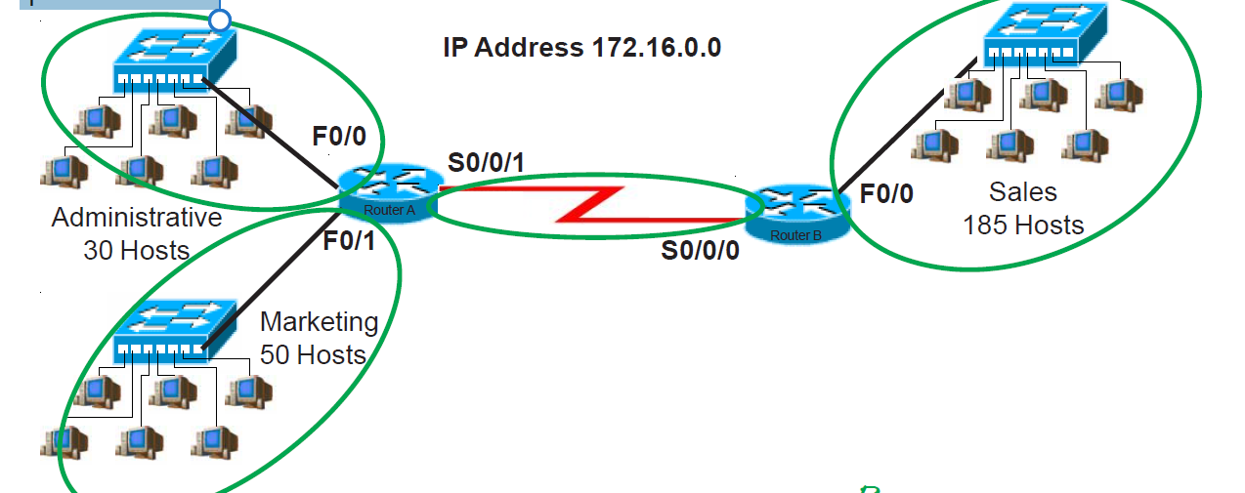

Available IP Block = 172.16 .0.0 255.255.0.0

Sales department will require a minimum block size of 256

New subnets 🡺 255.255.254.0 (/23)

|  |  |  |  |  |
| --- | --- | --- | --- | --- |
| **Subnets** | **Network Address** | **Subnet Mask** | **Usable host** | **Broadcast Address** |
| 0 | 172.16 .0.0 | 255.255.254.0 | **172.16 .0.1 - 197.16 .1.254** | 172.16 .1.255 |
| 1 | 172.16 .2.0 | 255.255.254.0 | **172.16 .2.1 - 197.16 .3.254** | 172.16 .3.255 |
| 2 | 172.16 .4.0 | 255.255.254.0 | **172.16 .4.1 - 197.16 .5.254** | 172.16 .5.255 |
| 3 | 172.16 .6.0 | 255.255.254.0 | **172.16 .6.1 - 197.16 .7.254** | 172.16 .7.255 |

* So**, Sales =172.16 .0.0 255.255.254.0 (/23)**

Provides 254 usable host address. Gives room for about 37% growth.

Subnet1; **172.16 .2.0 255.255.254.0** broken down further to smaller subnet to provide block size of 64 which serves for Administrative and Marketing department

New Subnets, 255.255.255.192 (/26)

|  |  |  |  |  |
| --- | --- | --- | --- | --- |
| **Subnets** | **Network Address** | **Subnet Mask** | **Usable host** | **Broadcast Address** |
| 0 | 172.16 .2.0 | 255.255.255.192 | **172.16 .2.1 - 197.16 .2.62** | 172.16 .2.63 |
| 1 | 172.16 .2.64 | 255.255.255.192 | **172.16 .2.65 - 197.16 .2.126** | 172.16 .2.127 |
| 2 | 172.16 .2.128 | 255.255.255.192 | **172.16 .2.129 - 197.16 .2.254** | 172.16 .2.255 |
| 3 | 172.16 .3.0 | 255.255.255.192 | **172.16 .3.1 - 197.16 .3.63** | 172.16 .3.64 |

So, **Marketing Dept. = 172.16 .2.0 255.255.255.192** (/26) = 62 usable host addresses

**Sales Department = 172.16** .2.64 **255.255.255.192** (/26) = 62 usable host addresses

Finally, we take subnet 172.16 .2.128 255.255.255.192, break it further into block size of 4 (/30) to serve for P2P connection

New Subnets: 16 subnets of (/30) are created from this

|  |  |  |  |  |
| --- | --- | --- | --- | --- |
| **Subnets** | **Network Address** | **Subnet Mask** | **Usable host (2)** | **Broadcast Address** |
| 0 | 172.16 .2.128 | 255.255.255.252 | **172.16 .2.129 - 172.16 .2.130** | 172.16 .2.131 |
| 1 | 172.16 .2.132 | 255.255.255.252 |  | 172.16 .2.135 |
| 2 | 172.16 .2.136 | 255.255.255.252 |  | 172.16 .2.139 |
| 3 | 172.16 .2.140 | 255.255.255.252 |  | 172.16 .2.143 |
| 4 | 172.16 .2.144 | 255.255.255.252 |  | 172.16 .2.147 |